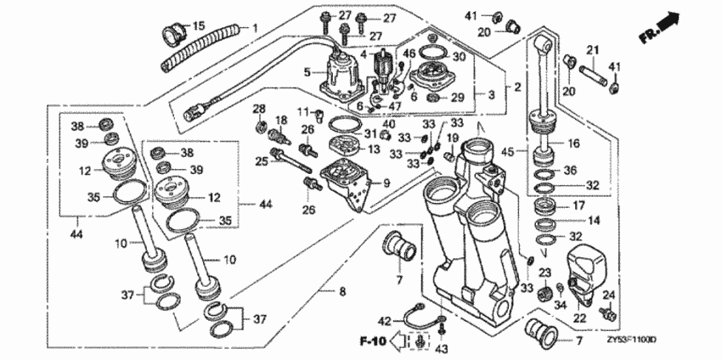

41; 94540-15029 — E-ring, 15mm -2шт

Power trim-tilt для Honda BF150 (BF150A4, )

20; 56513-ZV5-000 — Bush, lower cylinder 2шт

Power trim-tilt для Honda BF150 (BF150A4, )

21; 56532-ZW1-000 — Pin, upper cylinder

Power trim-tilt для Honda BF150 (BF150A4, )

